Apache solr

I used aws ec2 ubuntu for this assignment

Step1:created ec2 instance and allowed 8983 port

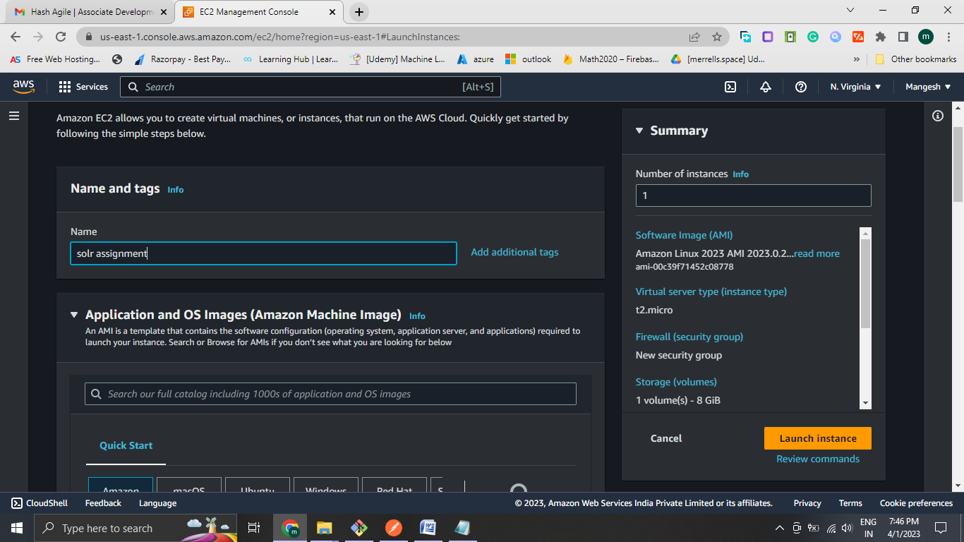 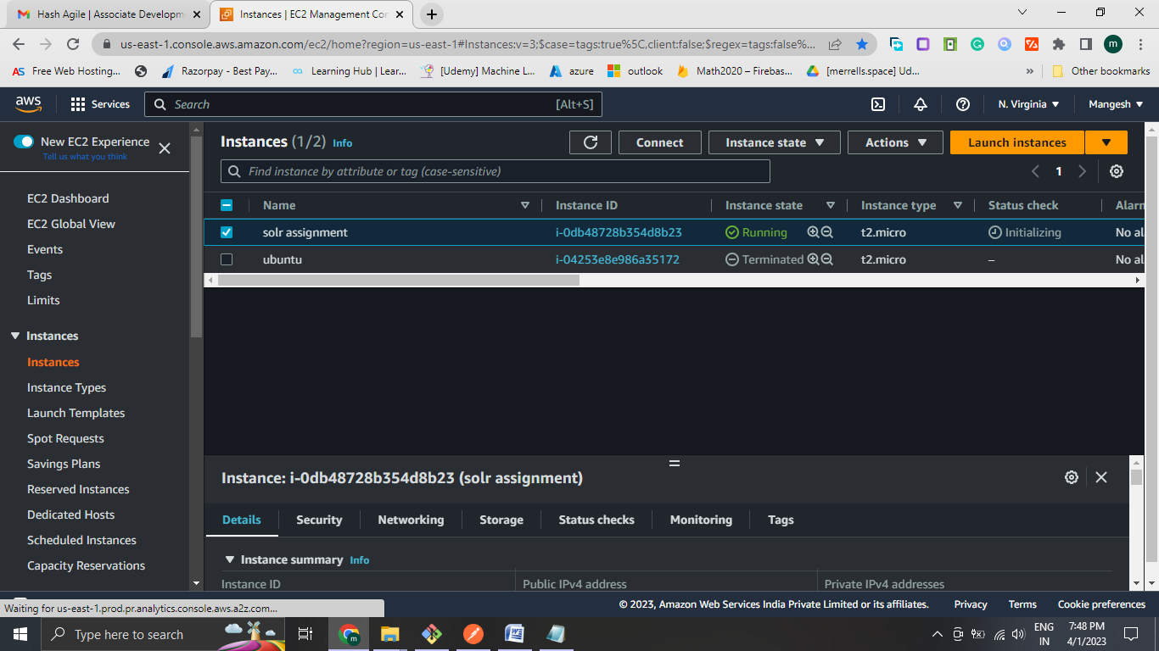

Step1:Update system

sudo apt-get update

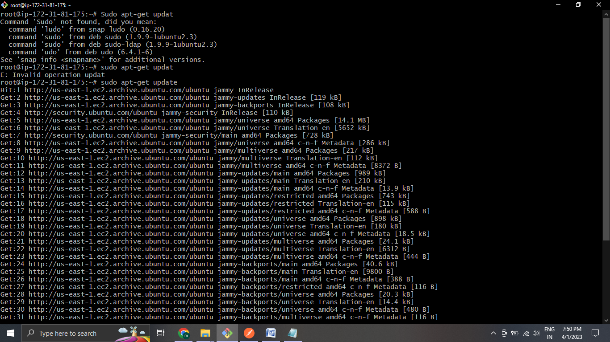

Step2 install java

sudo apt-get install python-software-properties -y

sudo add-apt-repository ppa:webupd8team/java -y

sudo apt-get update -y

sudo apt-get install default-jre default-jdk –y

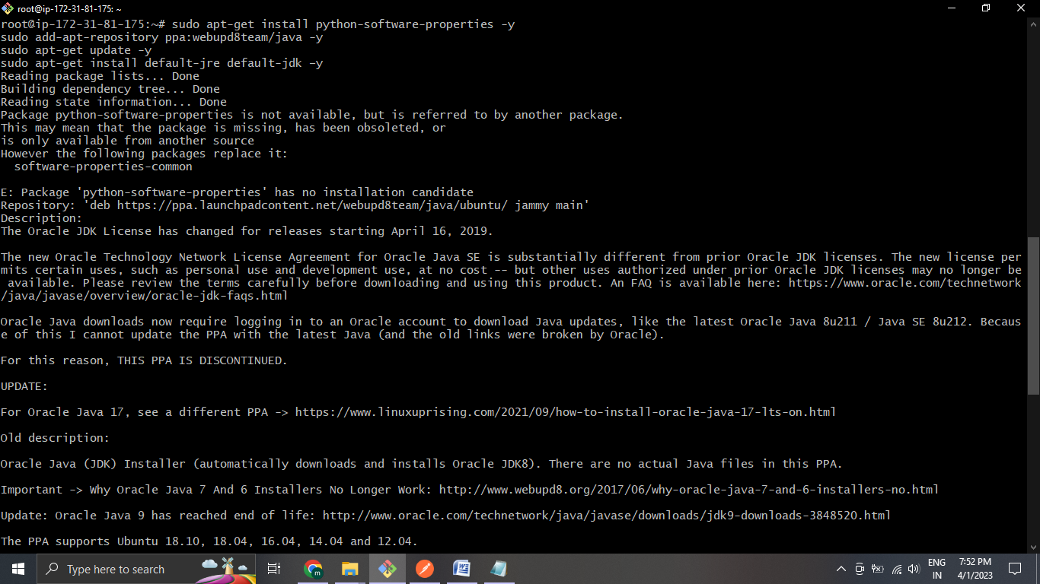

Step 3: Download Solr 8.2

cd /tmp

sudo wget <https://archive.apache.org/dist/lucene/solr/8.2.0/solr-8.2.0.tgz>

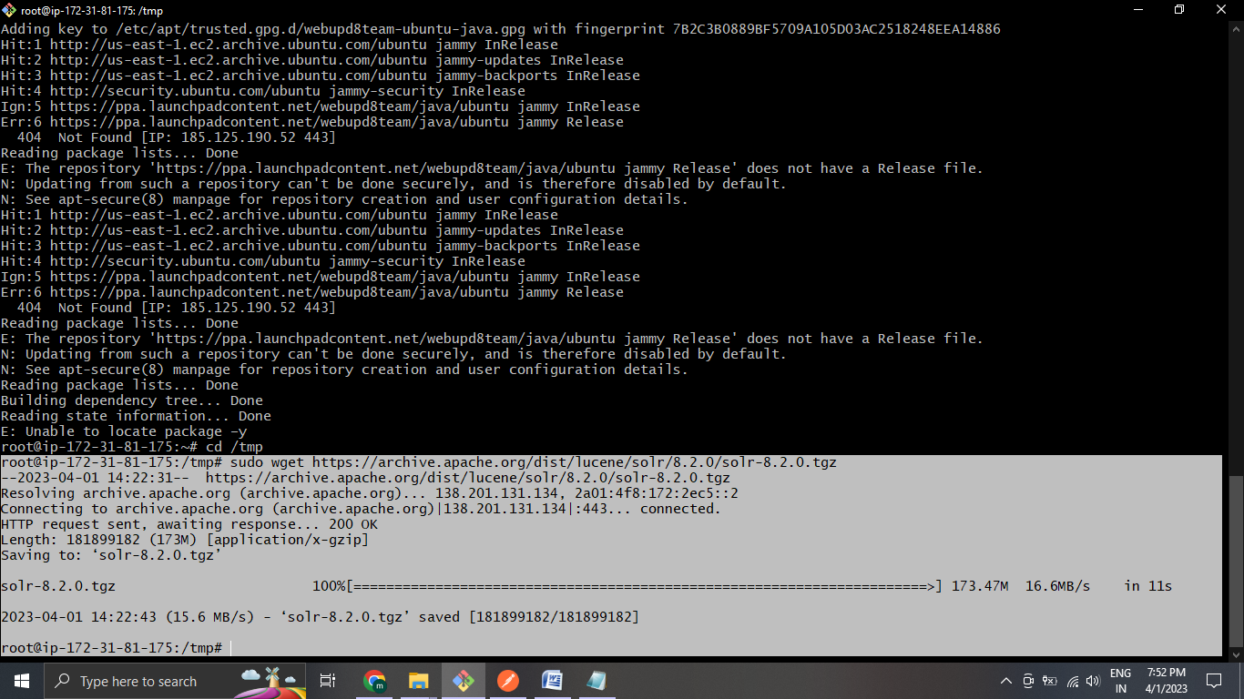

Step 4: Extract Solr 8.2

sudo tar xzf solr-8.2.0.tgz solr-8.2.0/bin/install_solr_service.sh --strip-components=2

sudo ./install_solr_service.sh solr-8.2.0.tgz

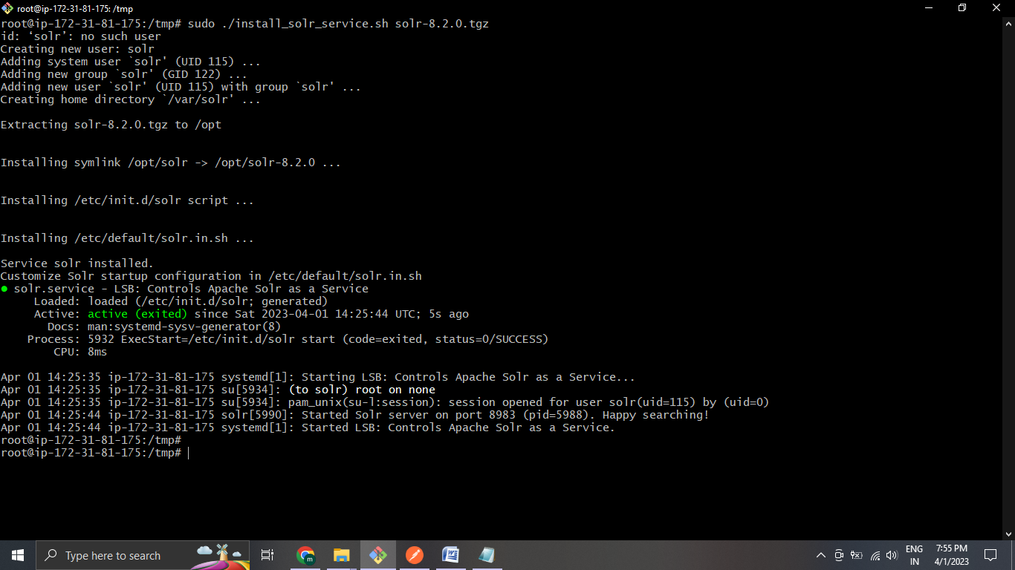

sudo systemctl status solr.service

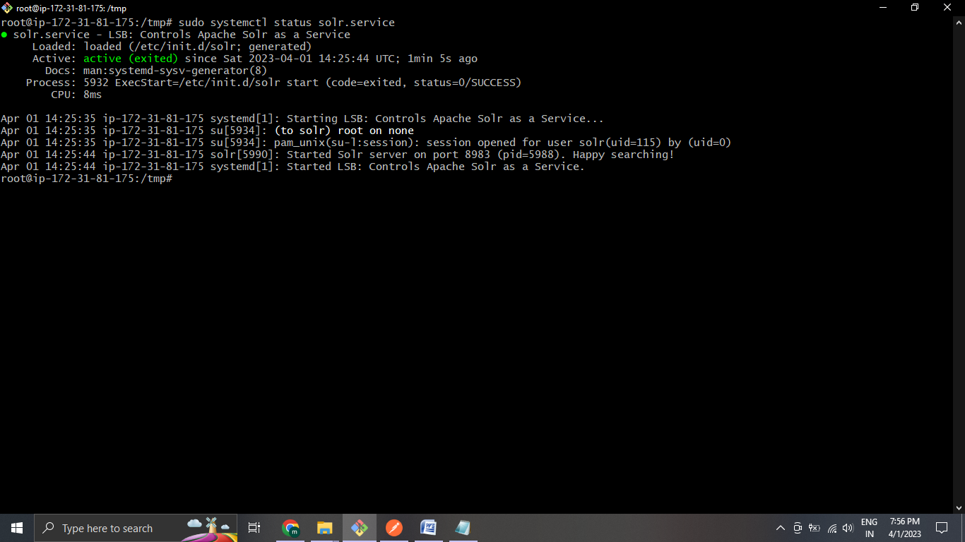

Step 5: Testing Solr

http://localhost:8983 or <http://ip_address:8983>

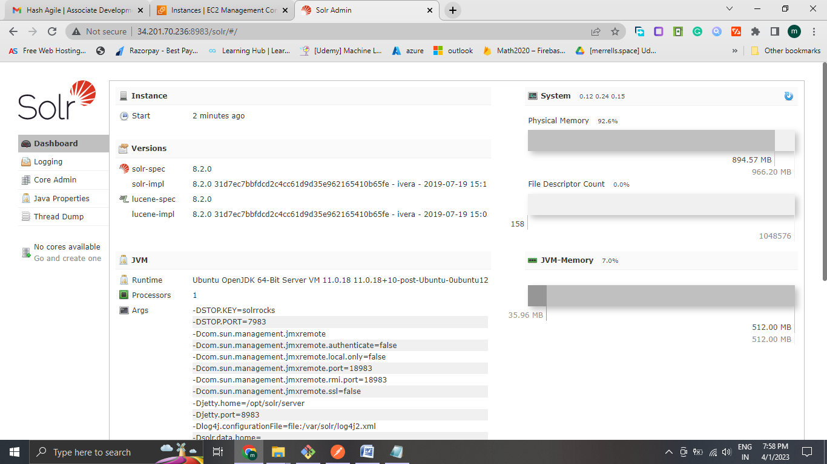

Step 7: Creating a Core

sudo su - solr -c "/opt/solr/bin/solr create -c core_name_here -n data_driven_schema_configs"

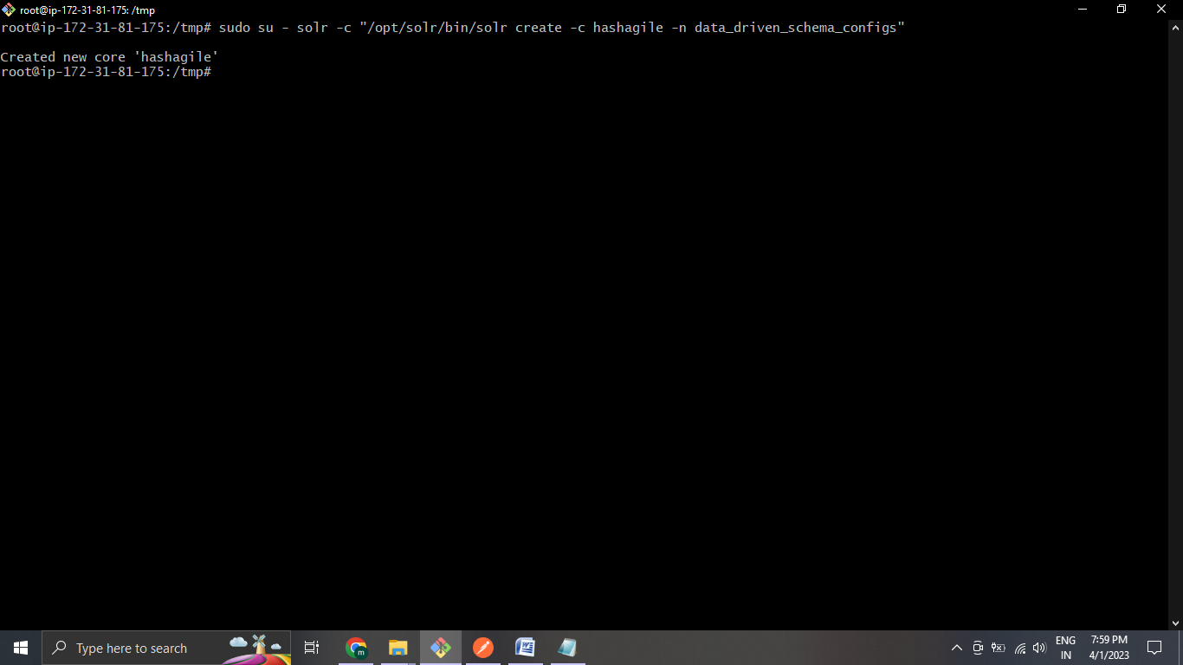

Step 8:Upload Data

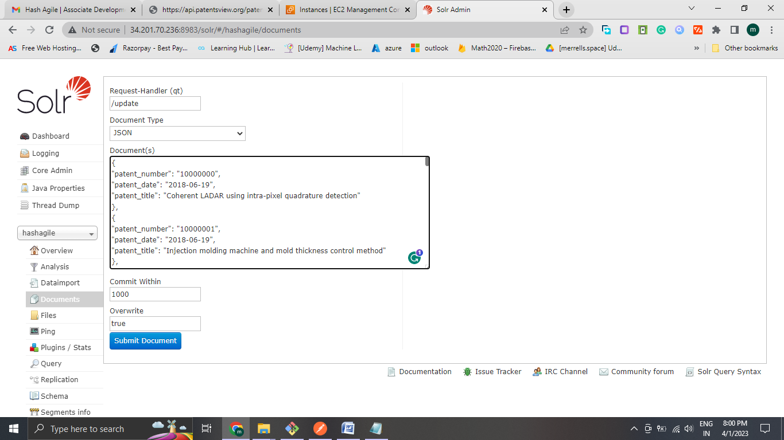

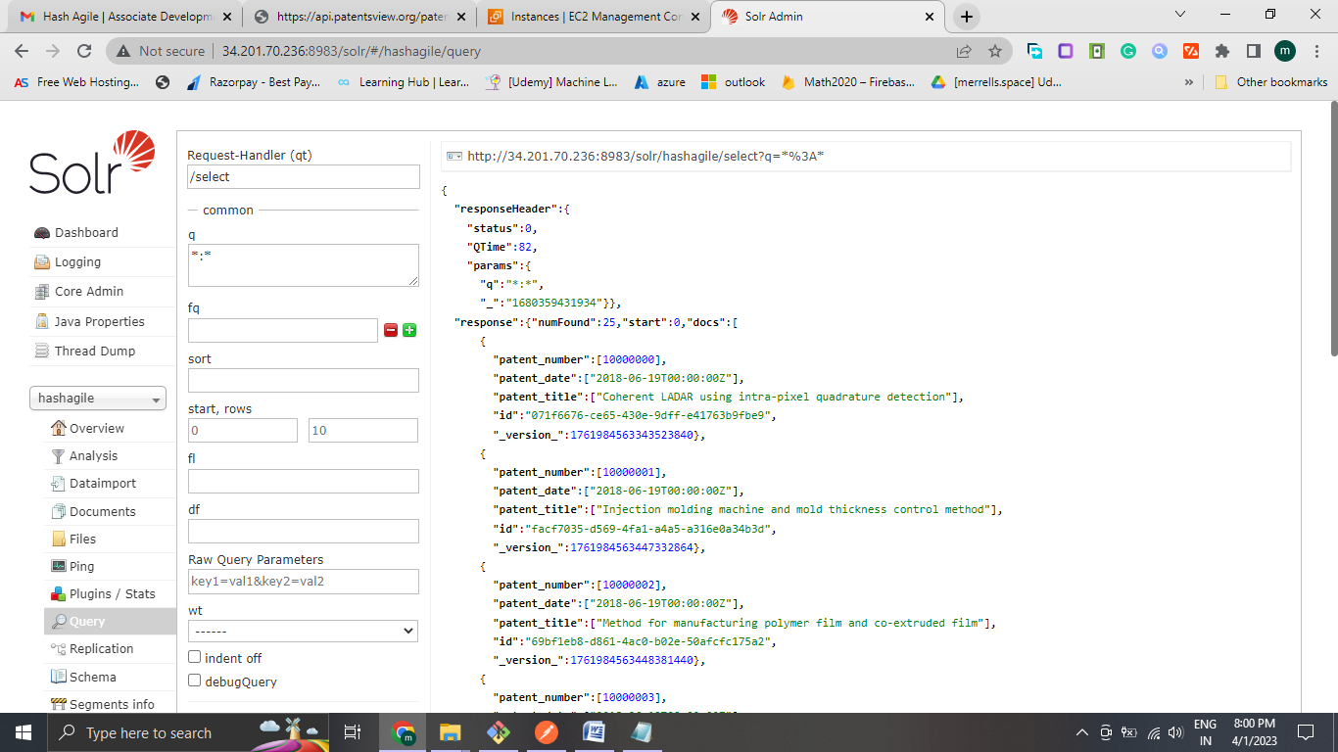

Create schema

